Name:
Date:
Pod:

Before Counting….

Estimate the number of Skittles in your package: | Take a photo of your Skittles.  Use the insert menu and insert via snapshot or use the mobile Google Docs app and insert with camera.
- Which color do you think your package has the most of:
- Which color do you think your package has the least of:

Count The Skittles
- Open up your Skittles package on a clean sheet of white paper and record the total:

- Fill in the table below.
AFTER you fill in the table, you may start eating your Skittles.
Color | Amount | Fraction | Reduced Fraction |  | 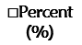
Orange
Red
Yellow
Green
Purple

△To figure out the decimal, take the numerator of the reduced fraction and divide it by the denominator. Round your answer to the hundredths place.

ㅁTo figure out the percent, remember it is PER cent or per 100. Per means divide, so divide by 100. This should move your numbers into the hundredths place.
✤To figure out the degrees in circle, remember that it is the FRACTION or PERCENTAGE of the circle. A circle has 360˚. Calculate the percent of 360˚ that that color represents. Round your answer to a whole number.

Create a Pie Chart
6. In the box below, use the insert menu to insert a pie chart.
In the upper right hand corner of the chart is square with an arrow to allow you to open the pie chart in Google Sheets. Edit the table so that the pie chart accurately represents the bag of Skittles. Click on “Update” in the chart you inserted.
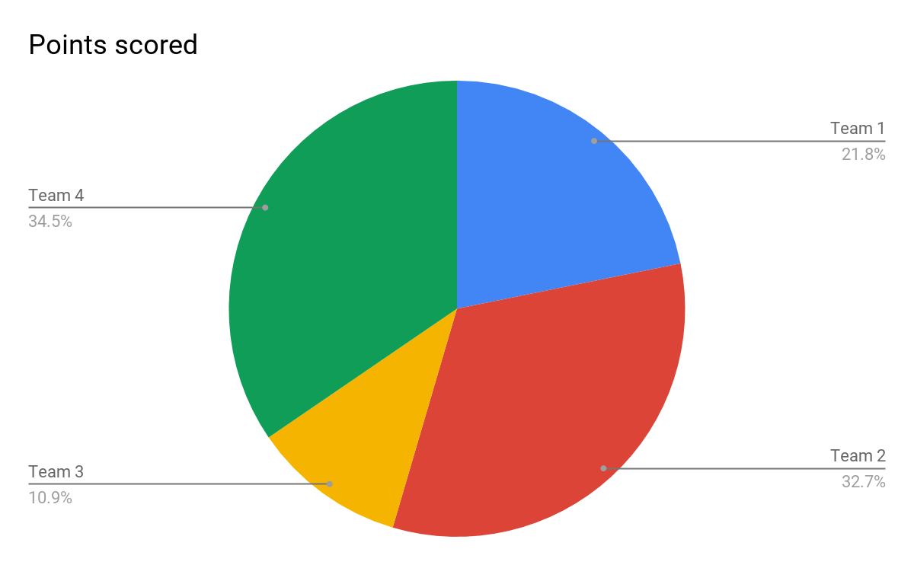

Make Your Own in Google Drawing
7. Use this template to create your own pie chart on a Google Drawing.
The protractor is provided for you. Look off to the right margin for a link to a YouTube video on how to make a pie chart. Trick is to hold down shift key when drawing or rotating shapes!!
Use the File menu in Google Drawing to download as PNG. Drag that downloaded image into the box below.

8. How do the pie charts compare?

Show Your Thinking
Show your math by typing linearly and then explaining reasoning. For example
=40% * 360˚ = 0.40*360 = 144˚
All of the circle would be 100%. 40% of the circle is less than half of the circle! Half of 360˚ is 180˚ so I would expect that the result of multiplying 40% and 360˚ is under 180, and it was!

Tip: use the g(math) Add-on to insert a quick sketch or to make math symbols in the document.

9. If there were a huge bag of 1,000 Skittles, how many of them would be red?

How did you figure that out?

10. How many of them would be yellow?

How did you figure that out?

11. If there were a bag of 75 Skittles, how many would be green?

How did you figure that out?

12. How many would be purple?

How did you figure that out?

13. What is the probability of getting a red or green Skittles from your bag?

How did you figure that out?

14. What was the hardest part of this activity?

15. What questions do you still have?

